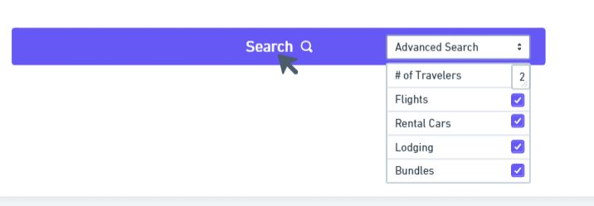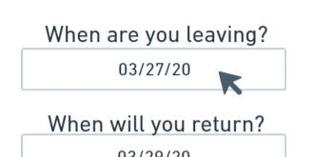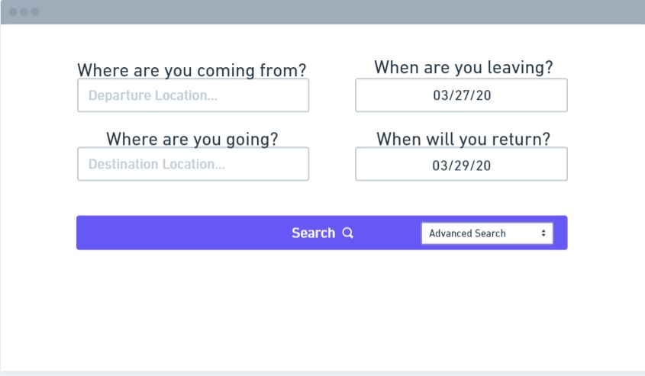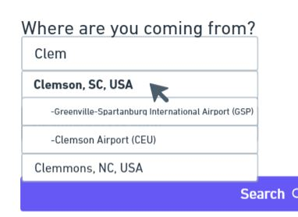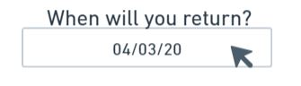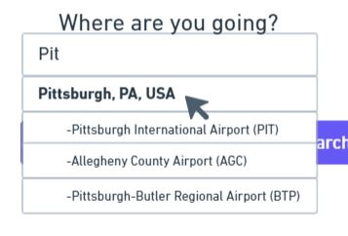

Sarah clicks the “Advanced Search” dropdown but decides to leave the default options selected to keep her search broad. She then clicks the Search button.

Sarah inputs her desired return date.

Sarah chooses her desired destination location after typing in the first few letters. She notices several popular airports listed below Pittsburgh, but decides to just select the city as she’s keeping her search broad for now.

Sarah notices that the default departure date is already set to the date she wants to leave. This is a welcome surprise for Sarah; she doesn’t have to do anything!

Sarah chooses her desired departure location after typing the first few letters of it. She is surprised at how easily it guessed where she wanted to leave from (based on her location and popular places).

Sarah opens the website and the first thing she notices is the Streamlined Search Interface. She likes how large it is and how obvious it is what information she needs to input to search for travel.